SK FINANCE

Vehicle Loan System

Fully Digitalized system to apply the Vehicle Loans

Contact : sasikumarcoder@gmail.com

2022

Sasikumar

Individual Development

3/27/2022

Before Login

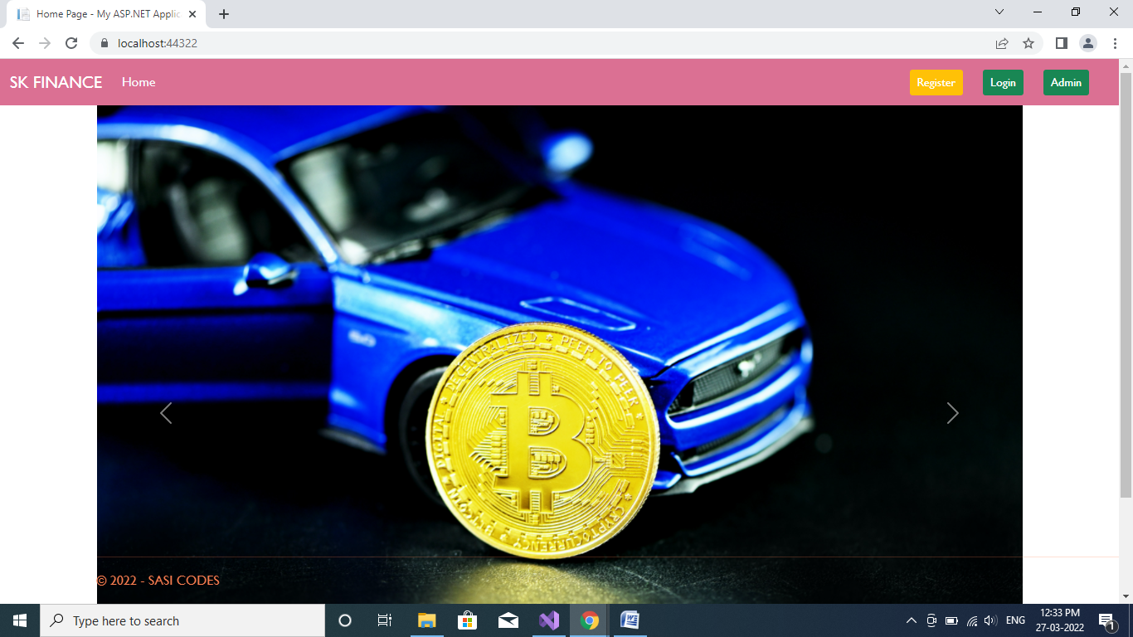

Create new Account:

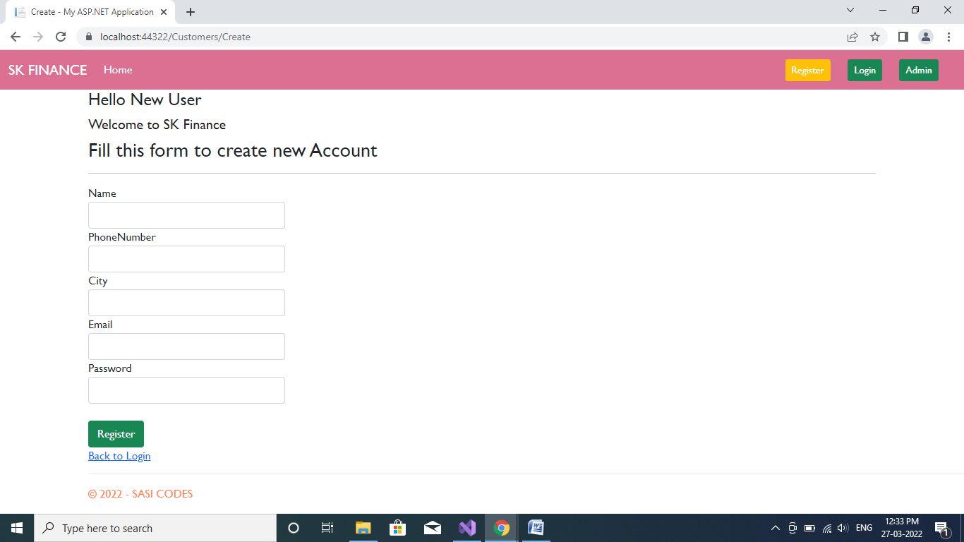

Login for Exsisting User:

(Before login don’t have any navigation links)

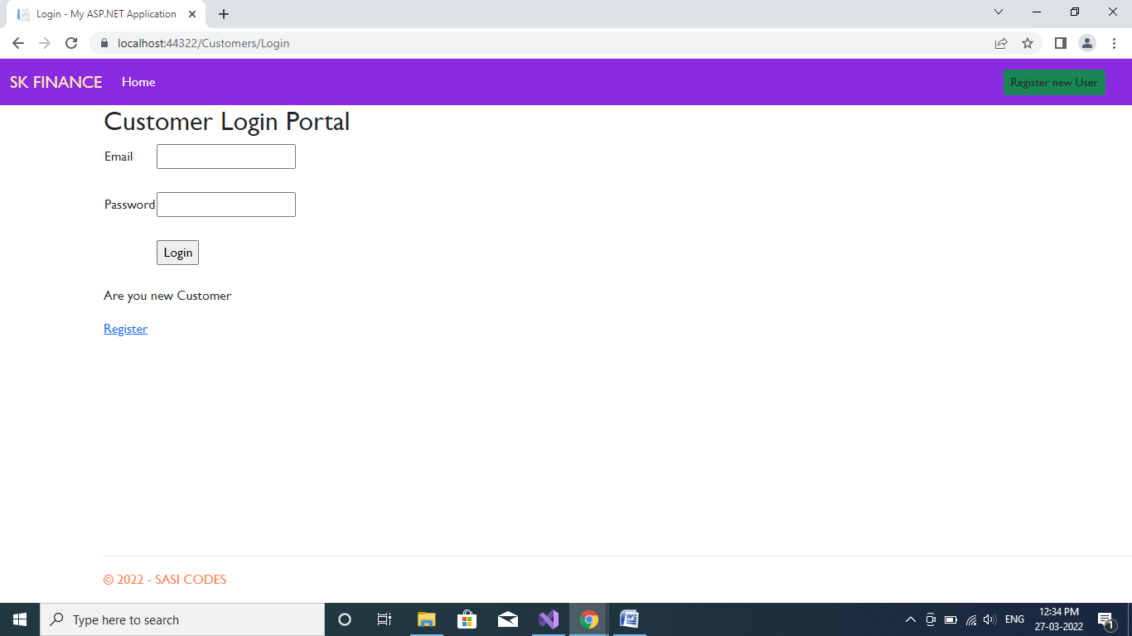

If you’re an admin:

(Before login don’t have any navigation links)

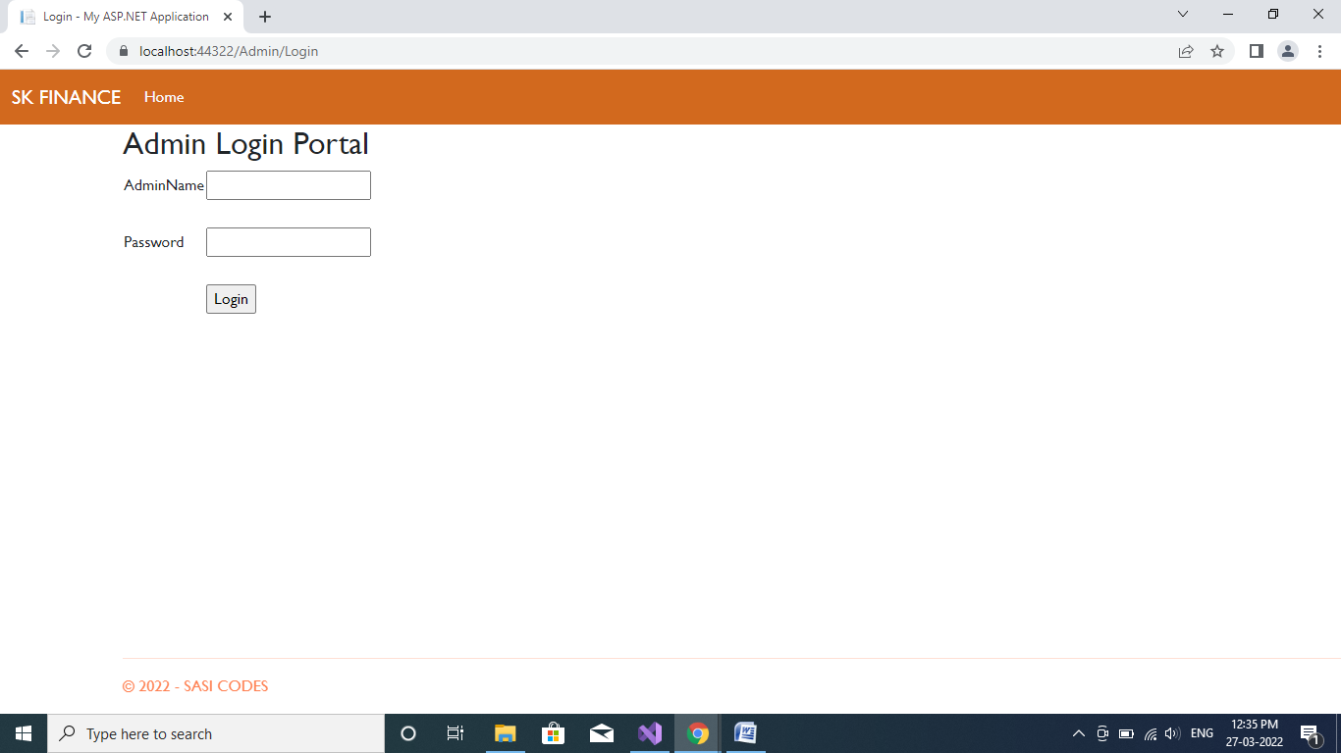

After Customer Login:

Dash Board:

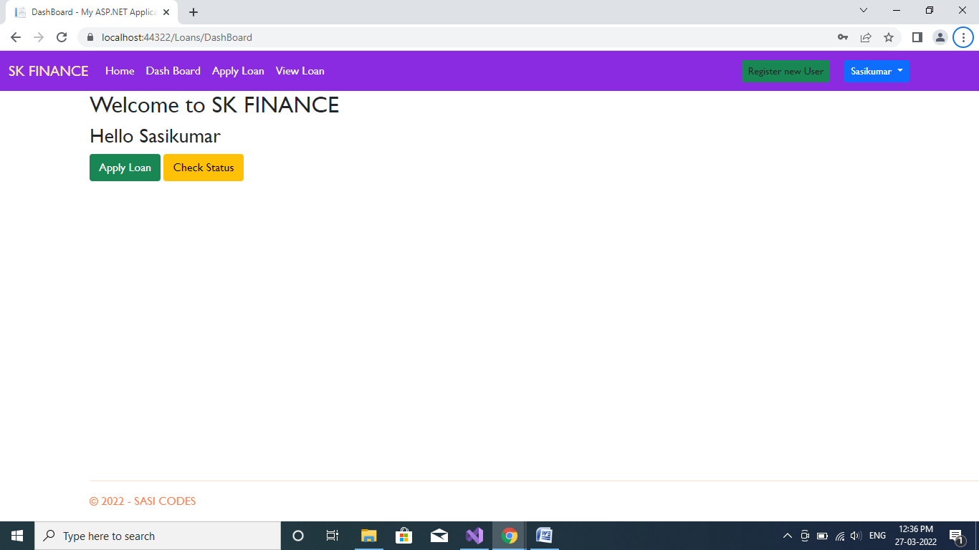

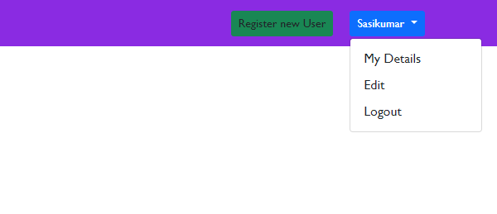

Apply Loan:

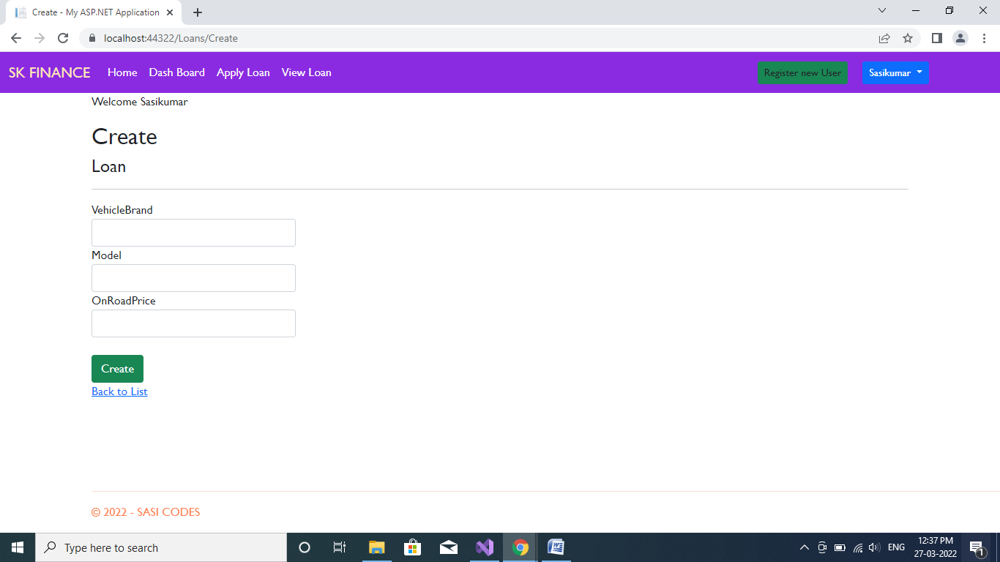

View Loan:

(Total Applied Loans for a single User)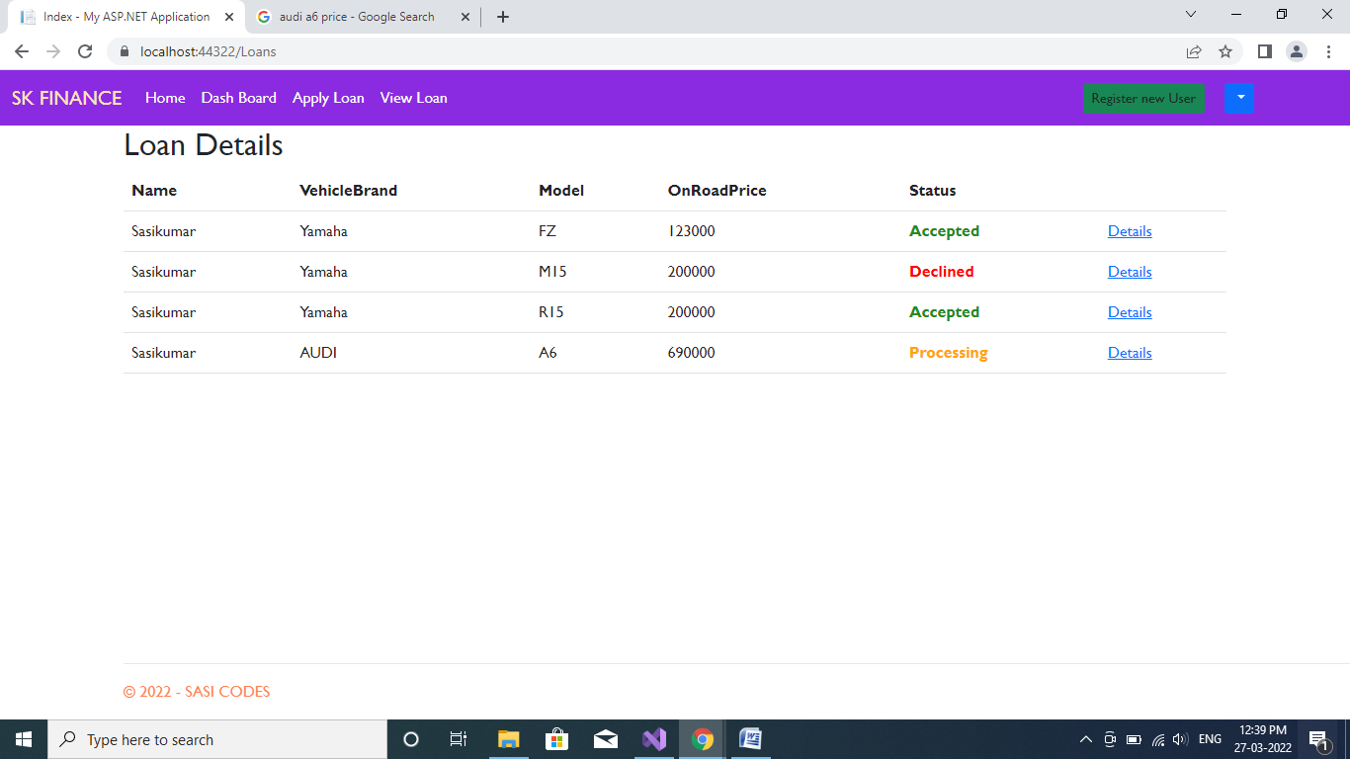

View Particular Loan:

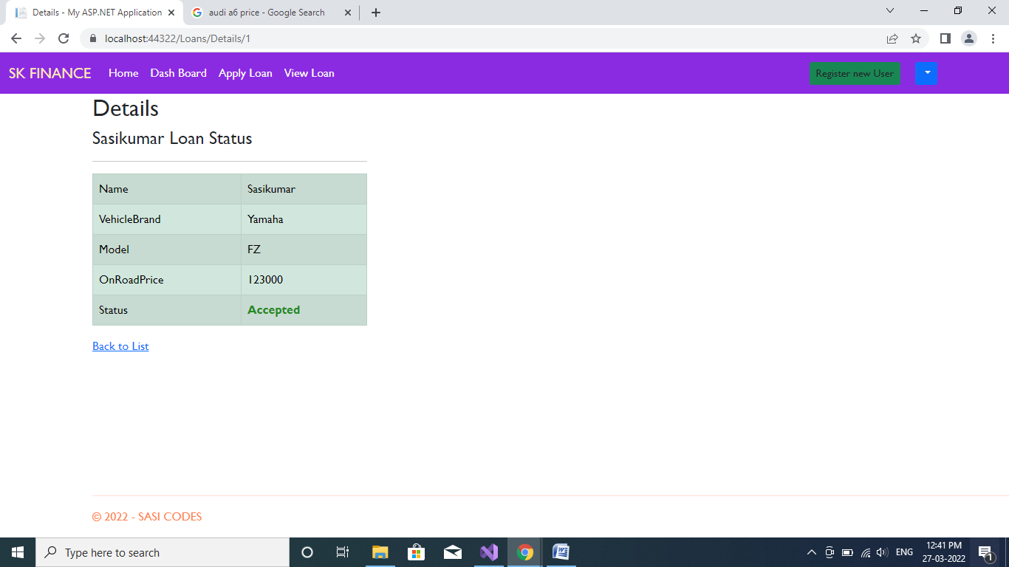

(Note: If loan is accepted text changed to Green and Delete loan button will be hided)

Denied Loans

: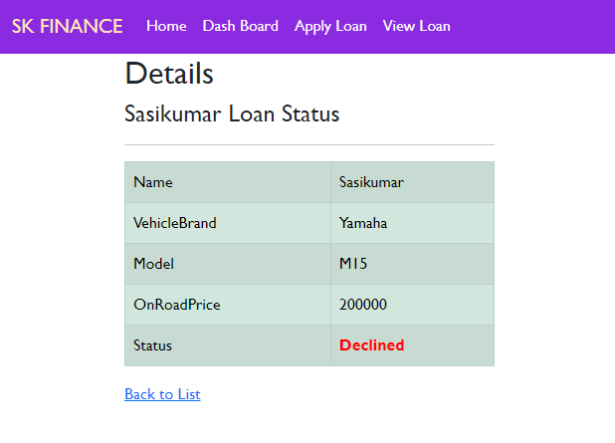

Pending Loans with Delete Button:

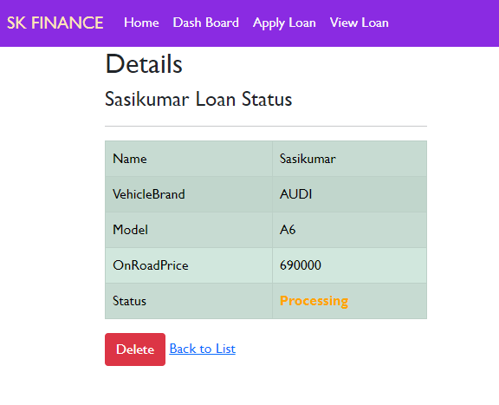

My Profile Button

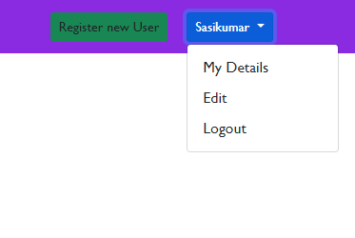

My Details Button:

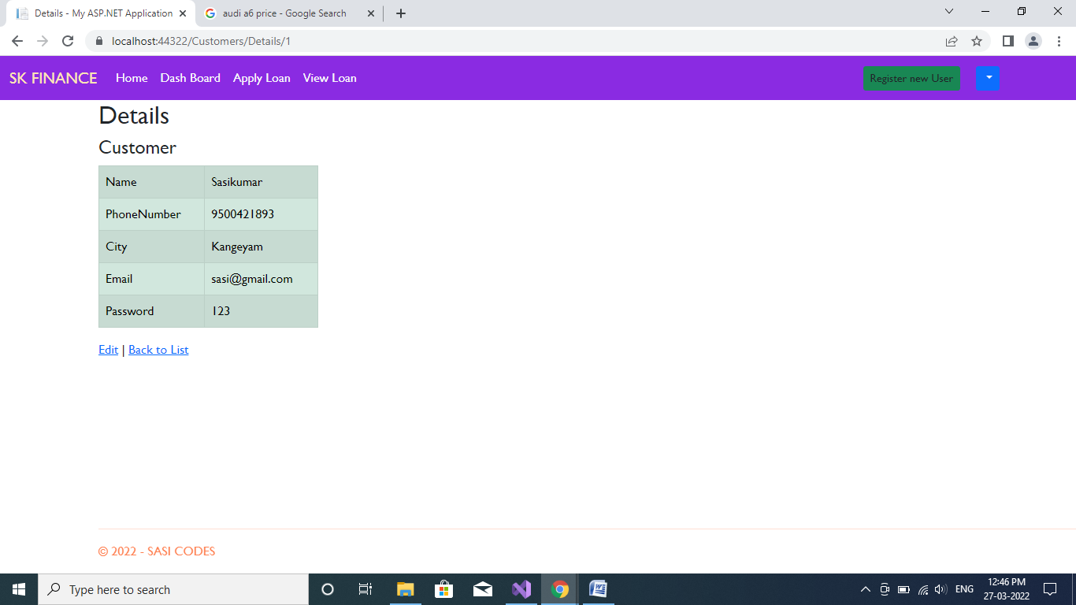

Edit Button for my Profile:

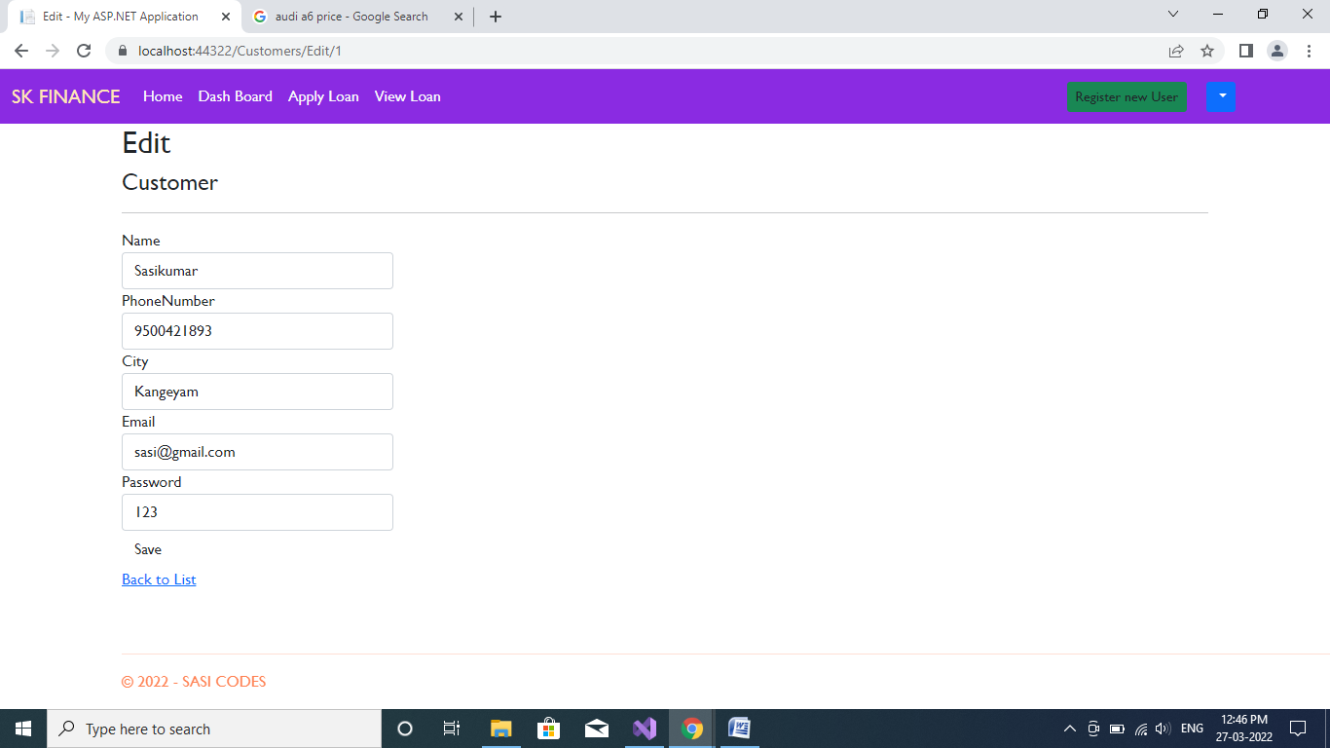

(Note: If you logout, redirect to Home page. Or click **HOME** Button the session will be Cleared)

ADMIN

Admin Login Portal

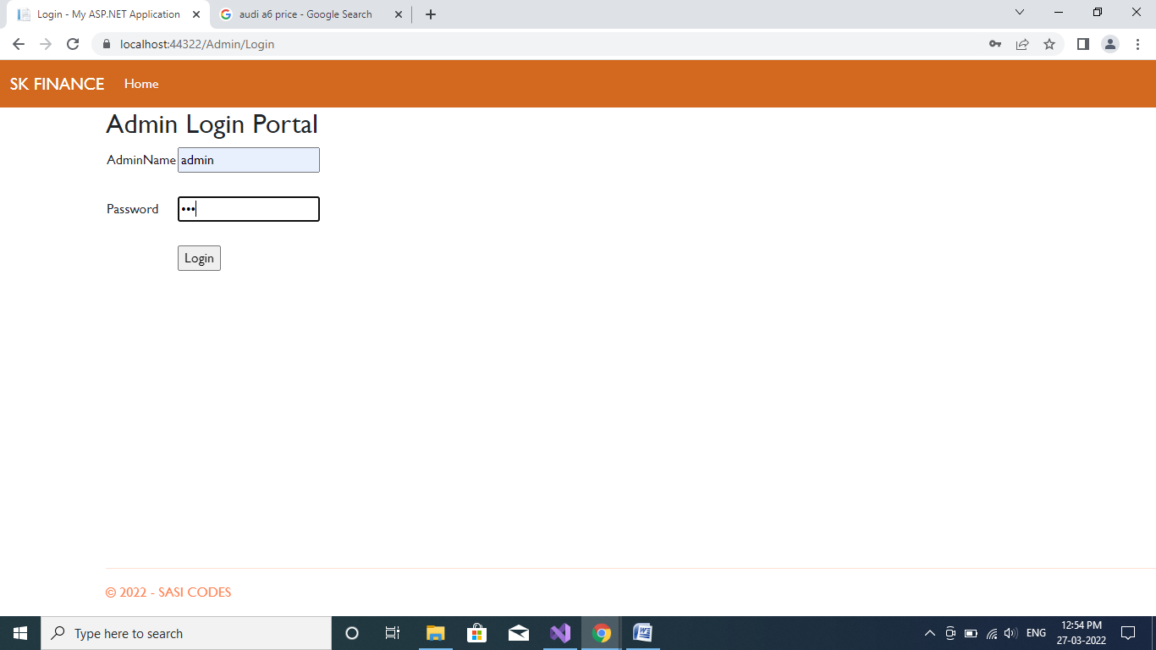

Dash Board for Admin

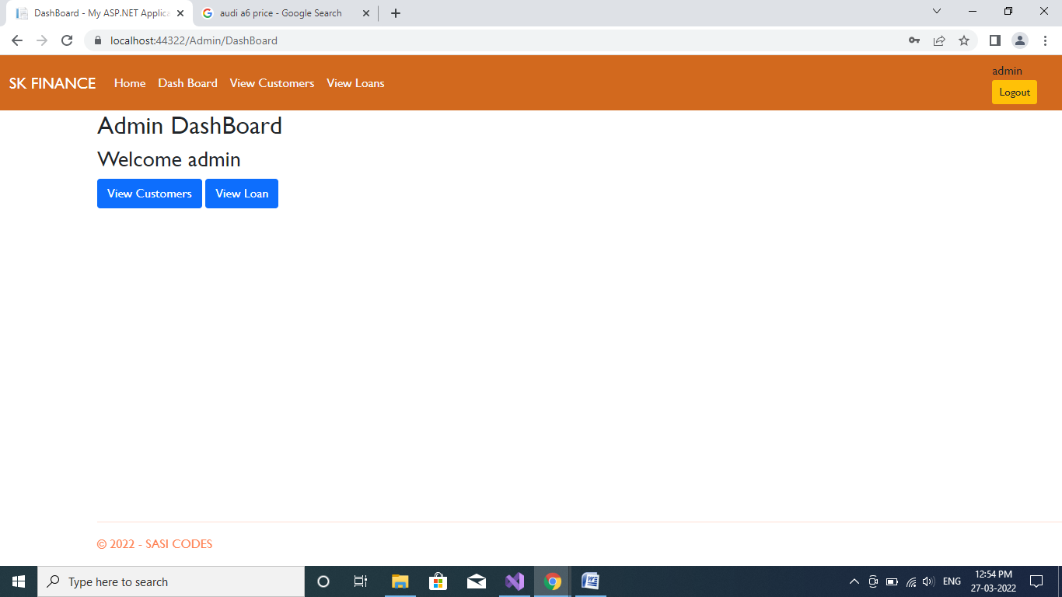

View All Customers List:

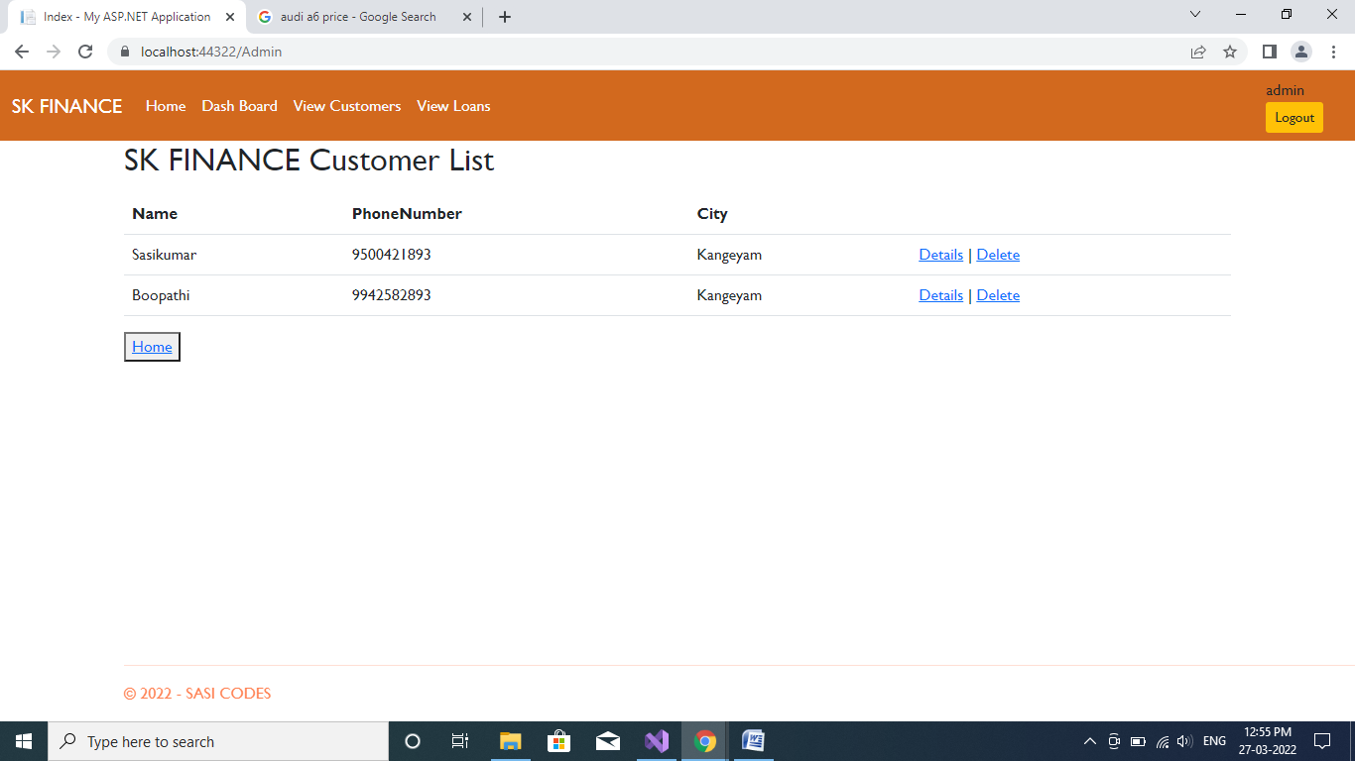

And Individual Details:

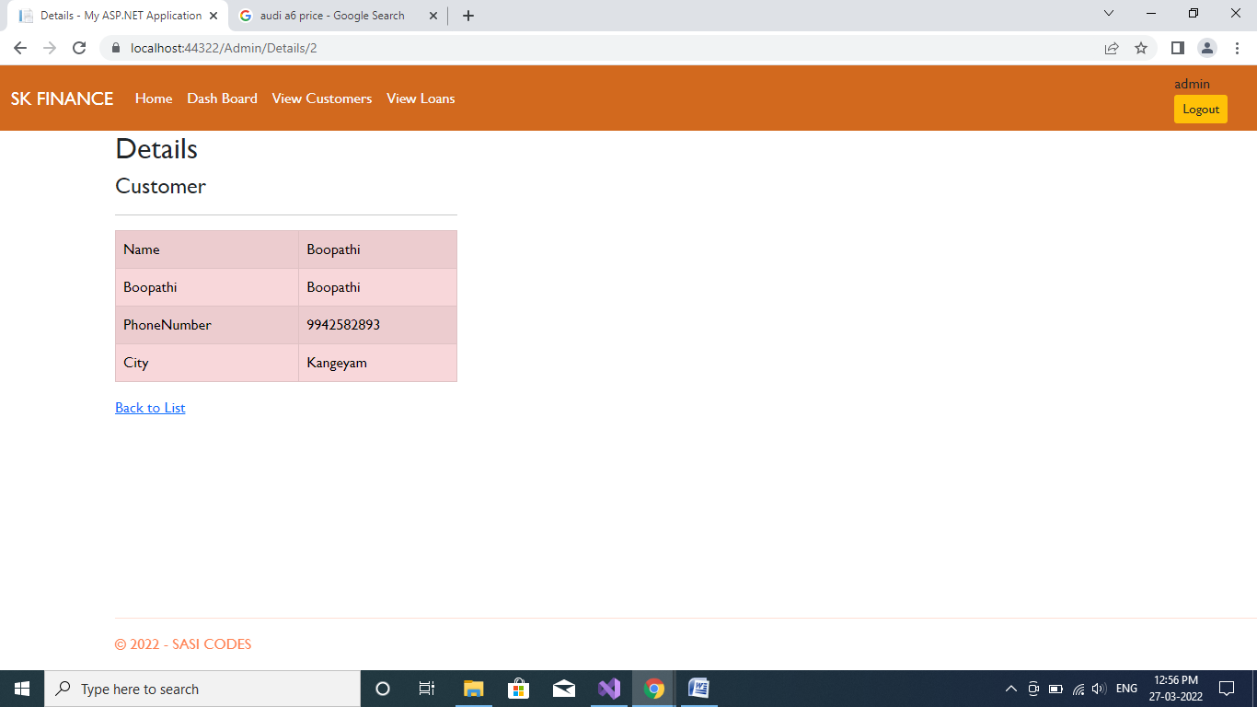

Applied Loan Details:

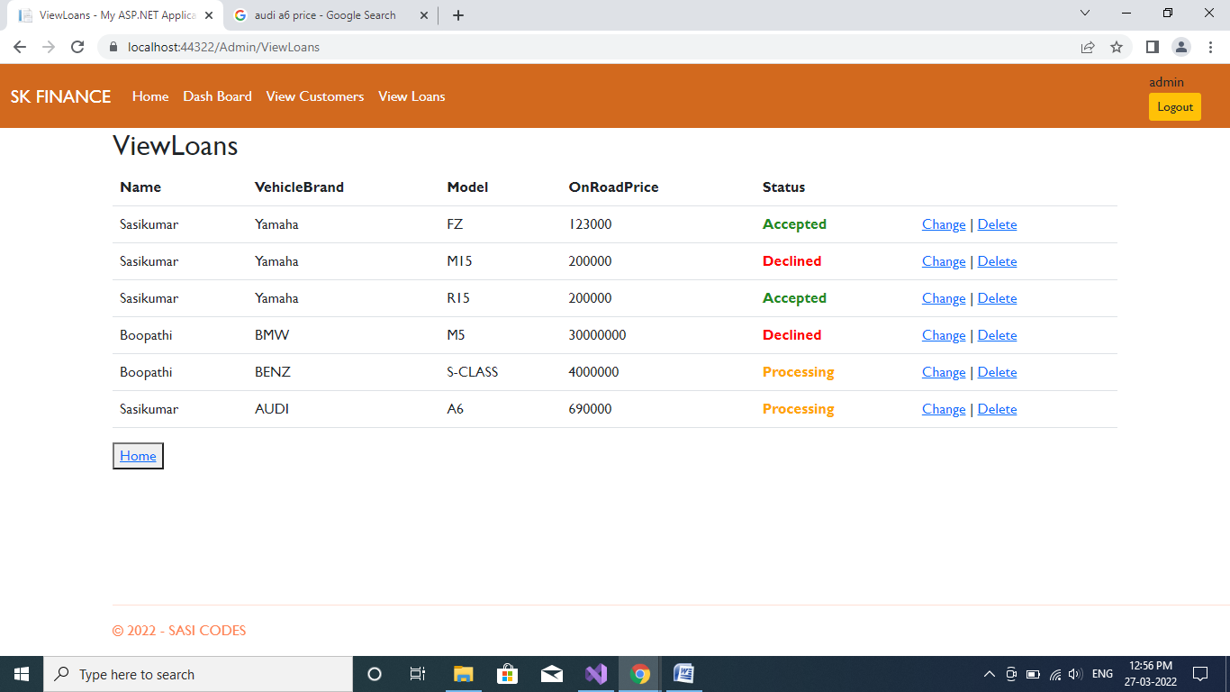(

IF you want to change the status press Change button to change the Status)

If you Click change button:

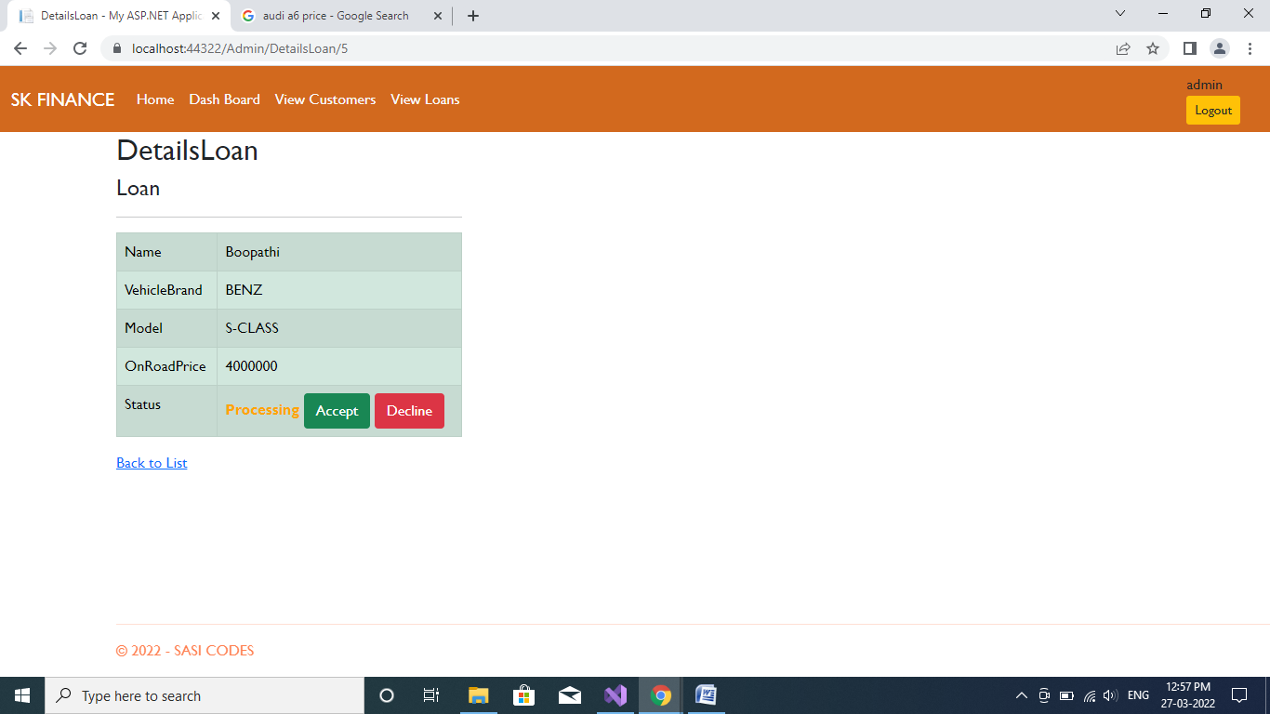

(Note: If Loan Status is Process means only **Accept** and **Decline** Button will be Appear.)

If Accept the Loan:

Button Will be hided

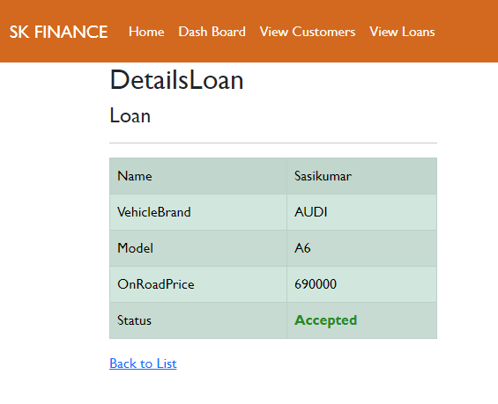

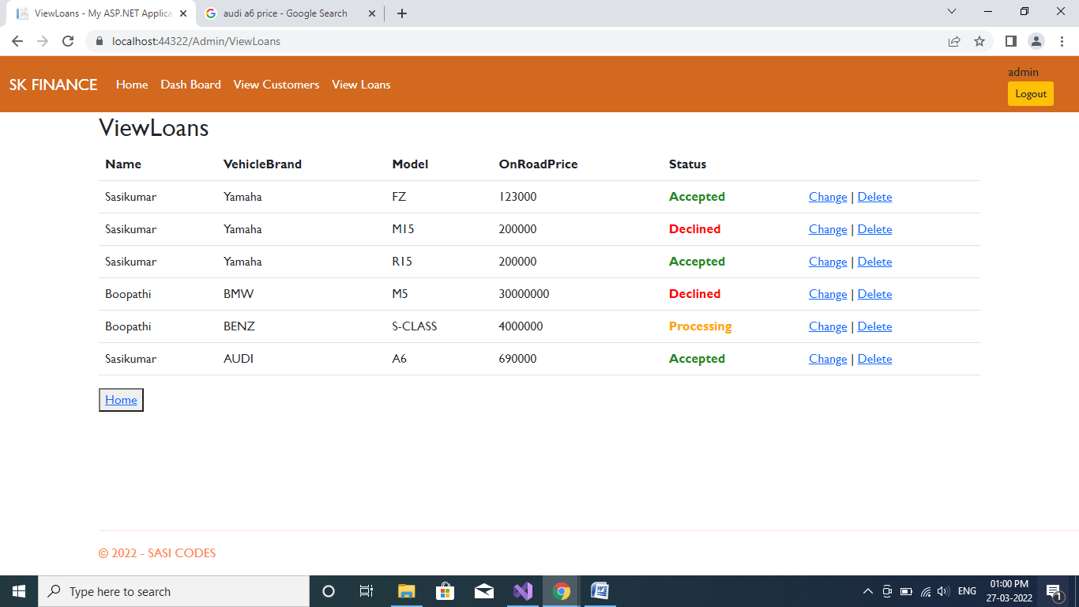

If You Press **logout** or **HOME** button session will be cleared



Thank You!